**INTRODUCTION**

**1.1 Introduction:**

The project entitled "STUDENT GRIEVANCE" is a web based site developed in many languages such as Html, Css, Sql, Bootstrap, Php, JavaScript.

A grievance may arise out of a decision or action reached or taken in the course of official duty by a member of the faculty, staff, or administration. The purpose of the grievance procedures is to provide a process for an impartial review of student-initiated concerns and to ensure that the rights of university students are properly recognized and protected.

Any student may file a grievance under this policy. The grievance can arise from any official faculty or staff action or decision deemed to be unjust or discriminatory by the student and is based upon violation of an institutional policy or written standard that protects every student. The goal of this process is to insure fair and equitable treatment of all students, to hold administrators, faculty and staff accountable for compliance with institutional policies and procedures. Resolution of student complaints, regardless of the outcome, also can improve a student's progress toward completion of a course or degree and ultimately success at the institution.

A student has standing to file a grievance under these procedures if he/she is enrolled in a course or was a student during the semester (or summer/intersession) prior to the time of filing, provided that person has attempted to resolve his or her complaint informally through those procedures discussed in Section IV above

The end user of this product is student where the website is hosted on the web and the administrator maintains the database.

**1.2 Necessity:**

A student has standing to file a grievance under these procedures if he/she is enrolled in a course or was a student during the semester (or summer/intersession) prior to the time of filing, provided that person has attempted to resolve his or her complaint informally through those procedures discussed by teachers.

If the student may request an official examination of the facts by presenting a completed grievance form to the Student. To complete the form, the student must prepare a specific written statement of how the decision or action is unfair and harmful to the grievant and list the University policies, regulations, or rules that have been violated. A brief narrative (including the names of individuals and/or departments and how they are involved, specific dates, times, and other relevant information) is required to support the allegations made. The student should also specify the remedies requested. Remedies under these procedures are generally limited to restoring losses suffered by a student or making changes in University policy, practice, procedures or training. Monetary damages, fines or penalties, or disciplinary action against an individual who is the subject of the grievance are not remedies available to the student under these guidelines. The Student Grievance Form may be obtained from the Student. The Student may assist in preparing the grievance document to ensure its clarity.

**1.3 Objective:**

* Less time taken.
* Data can be easily found.
* More value.
* Satisfaction of user.
* Reduced manual working.
* User Friendly.

**1.4 Drawback of Existing System:**

* Data can be loses
* This system maintain regularly
* There is security and privacy may occure
* This is large process to maintain all user details

**1.4 Theme**

A grievance may arise out of a decision or action reached or taken in the course of official duty by a member of the faculty, staff, or administration of College. The purpose of the grievance procedures is to provide a process for an impartial review of student-initiated concerns and to ensure that the rights of college students are properly recognized and protected

**1.5 Organization of Report:**

The various chapters included in this project are:

**Chapter 1:** Introduction contains the information to the ‘STUDENT GRIVANCE’ need for computerization, objectives and theme of the project.

**Chapter 2:** Literature survey contains Existing System and Proposed System of student Grievance.

**Chapter 3:** System Development encapsulates the platform details and the design part contains the feature of website to be used for development of the Student Grievance support system with the help of UML diagrams such as data flow diagrams, entity relationship diagram and the use case diagram.

**Chapter 4:** Comparision between the existing system and proposed system and the testing method that are used to test the website.

**Chapter 5:** This is the last chapter of the project. It gives the conclusion to this extensive report of the project.

**2.LITERATURE SURVEY**

This website basically deals with the ease of student Grievance support system. for the users. This website makes the work of checking the available student Grievance details and displaying information related to them.

The website contains the options of selecting the registration with multiple choices of branches. The alternative/option that customer or user have clicked on will be treated as the entered option of the authorized user. If User wants to select the registration, then they have to give his/her personal Information like name, email id and other information.

This website has the ability to add, update and delete the records wherever and whenever needed. It helps in checking details of upcoming events, updates etc. This website of the student grievance support system, describes the complete information of the to a user of grievance handling to the user on website. The main purpose fullfilled by this website is that it avoids and reduces the task of the user and related details about it.

**2.1 Requirement Elicitation**

It is very essential to gather information for the project which is being developed. This is the first step in software development life cycle which is must for every software developer. In this step the specified members of developing team communicate with students to gather the requirement for the project that is to be developed.

**2.2 Requirement Analysis:**

The main aim is to provide secure and efficient facilities to the Student Grievance Support system to student over the internet. It is based on Client/Server.

The students can login through the secured web page by their account login id and password. Users will have all options and features like account details, student information, roll no, phone number, address, change pin / passwords, etc.

The network chosen for this application is Client/Server model as it provides adequate security .

User can login, select the grievance type, write the details about grievance, request for the proper solution etc.

**2.3 Software requirement specification:**

**2.3.1 Purpose:**

* Quick, simple, authenticated access to accounts via the desktop, PC, or the smartphone.
* In student Grievance support system, the administrator is present for managing daily analysis.
* In this project client /customer side is platform independent and user friendly for effective facility.

Improved data security, restricting unauthorized access. This project aspires to provide easy solution on the grievance. The main aim is to provide secure and fair means and delivering facilities to the students over the internet. It is based on client server.

The students can login through the secured webpage by thier account login I'd and password. Users will have all options and features like college details, change pin/password etc.

**2.3.3 Product Perspective:**

* **System interfaces** – The platform used for system implementation is wamp server and SQL.
* **Hardware interfaces**– Monitor, keyboard, Mouse, etc.
* **Software interfaces**–The frontend for this project is Html, Css, Java Script and whereas backend is Sql and Php.

**2.3.4 Product function:**

The input is regarding to various account details such as add, remove, update, etc. which is stored in the SQL and it is been retrieved & displayed to the user in the form of java whenever user wants to view his/her details.

**3. Platform Details**

* 1. **Software Requirements:**
* Language : Html, Sql, Css, Js,Php
* Database : SQL
* Operating System : Windows NT/98/2000/XP/7/8/10
  1. **Hardware Requirements:**
* Processor : Pentium III onwards
* RAM : 3 GB
* Hard Disk : 50 GB
* Monitor : CRT/LCD/LED
* Keyboard : Any QWERTY keyboard
* Mouse : Mechanical/Optical mouse

**4. UML Diagrams**

**4.1 E-R Diagrams:**

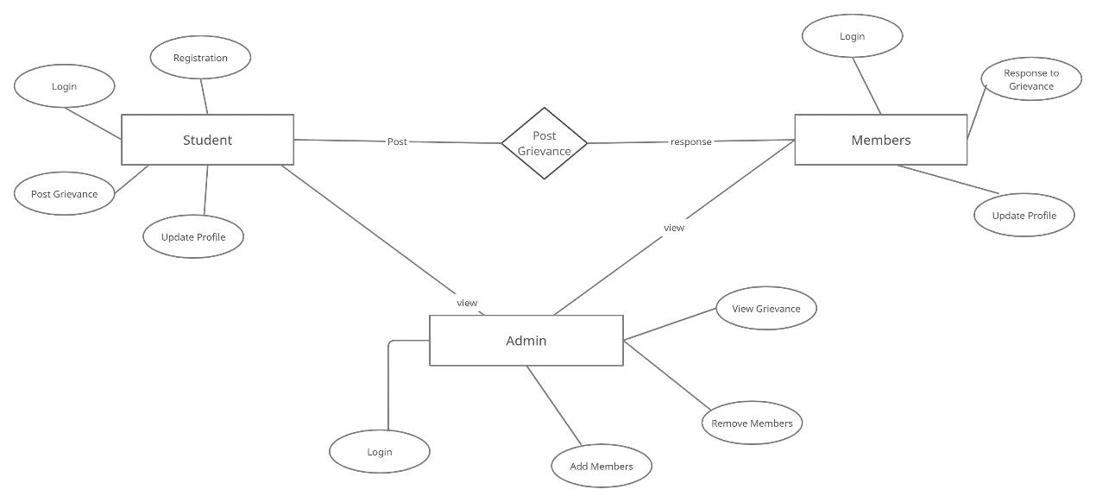

Figure 3.2.1 : ER diagram of Student Grievance

**4.2 Use Case Diagram:**

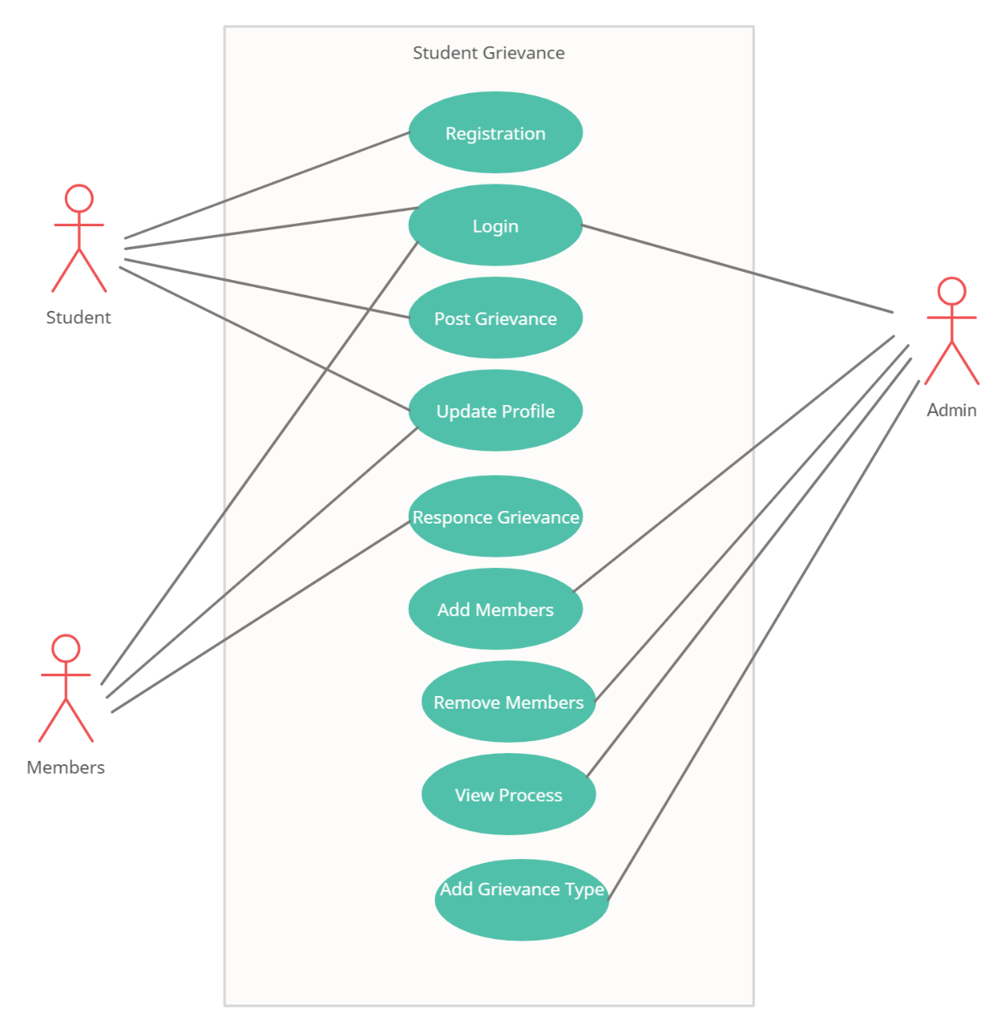

Figure 3.2.2: Use case diagram for Student Grievance

UNIT TESTING

MODULE TESTING

SUB-SYSTEM TESING

SYSTEM TESTING

ACCEPTANCE TESTING

Component Testing

Integration Testing

User Testing

**4.3 Data Flow Diagram(DFD)**

.

LEVEL 0:

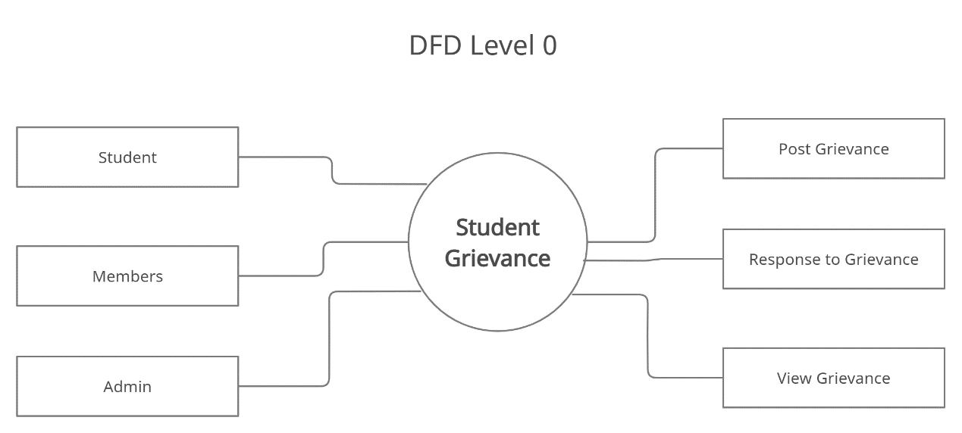

Figure 3.2.3 : DFD level 0 for Student Grievance

LEVEL 1:

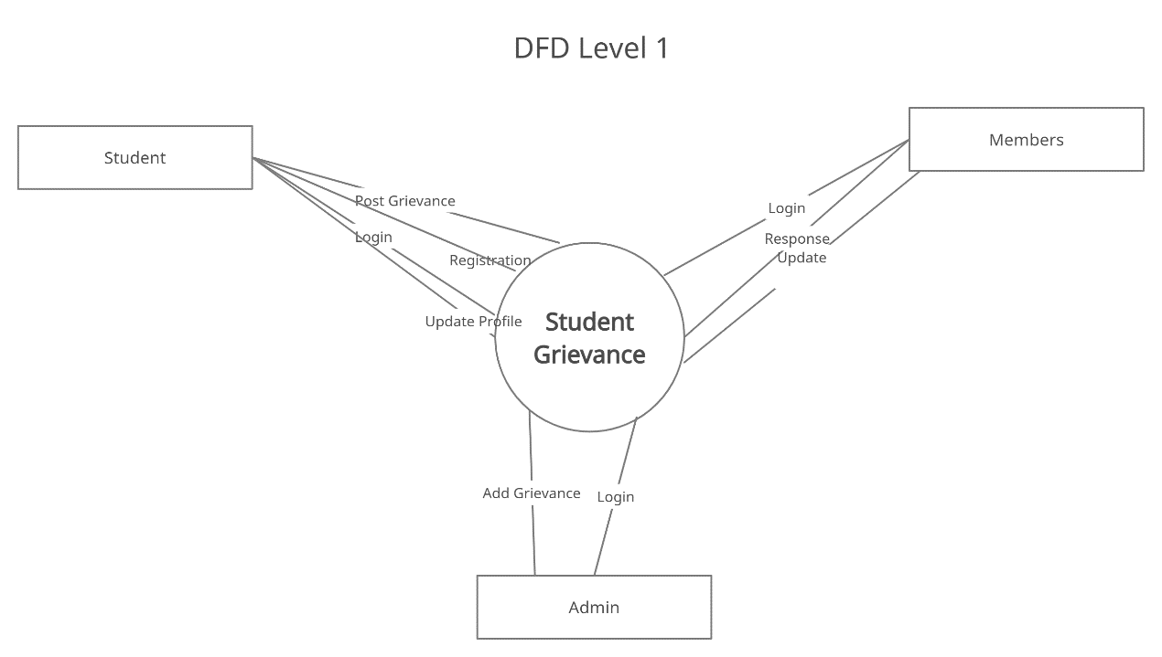

Figure 3.2.5 : DFD level 1 for Student Grievance

**4.4 Sequence Digram:**

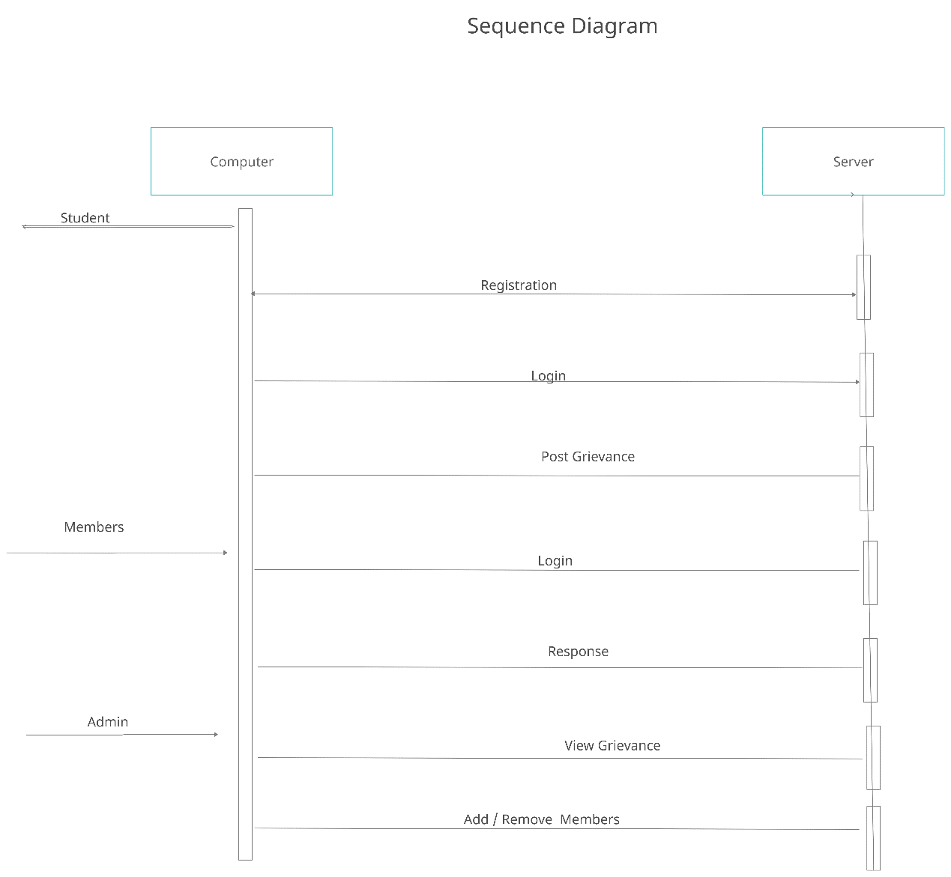

Figure 3.2.5 : Sequence diagram of student Grievance

**5. Systems implementation**

1. Defining how the information system should be built (i.e., physical system design),
2. Ensuring that the information system is operational and used,
3. Ensuring that the information system meets quality standard (i.e., quality assurance).

**5.1 Systems design:**

1. Conceptual design – what the system should do
2. Logical design – what the system should look to the user
3. Physical design – how the system should be built

**5.2 Physical system design using structured design approach:**

→  To produce a system that is easy to read, code, and maintain

1.      Factoring: decomposition

2.      Span of control: 9 subordinate modules

3.      Reasonable size: 50-100 LOC

4.      Coupling: minimize inter-module dependency

5.      Cohesion: single module functionality

6.      Shared use: multiple calls to lower level modules from different bosses

**5.3 Structured design tools:**

•        Organization of programs and program modules (structure chart)

•        Processing logic specification in each module (pseudocode)

**5.4 Structure chart:**

1. how the various program parts/modules of an information system are physically organized hierarchically
2. how the modules communicate with each other through data couple (data exchange) and flag (control/message)
3. how the modules are related to each other in terms of sequence, selection, and repetition

**5.5 Symbols:**

|  |  |
| --- | --- |
| **Components** | **Symbol** |
| Module | Rectangle |
| Data couple | Clear circle with out arrow |
| Control flag | Filled circle with out arrow |
| Conditional processing/selection | Diamond |
| Repetition | A curved line intersecting the connection to the modules |
| Predefined module | Rectangle with a vertical bar on each side |

**PERFORMANCE ANALYSIS**

**8.1. Present system**

The developed system is an innovation in the area of commerce. In the existing system the no. of staff required for completing the work is more, while the new system requires lesser staffs generally.

The data entry process requires the data on the paper, which is then feed into the application by the operator while doing so; the data entry operator has to look into the paper again &again and thus the chances of in accuracies in the typed contents increases. Also the process includes higher transportation cost, increased handling cost, more time delays, low accuracy, more usage of resources like registers, books, papers, etc.

**8.2. Proposed system**

“Why an Student Grievance Support System?”

A grievance may arise out of a decision or action reached or taken in the course of official duty by a member of the faculty, staff, or administration of college. The purpose of the grievance procedures is to provide a process for an impartial review of student-initiated concerns and to ensure that the rights of college students are properly recognized and protected.

**8.3. Benefits of the system**

* Quick, authenticated access to accounts via the desktop.
* Easily scalable to grow with changing system requirement.
* Enterprise wide access to information.
* Improved information security, restricting unauthorized access.
* Minimize Human's Effort's.

In manual system, much storage space for data files is required so to overcome this problem, on automated well managed database is developed for saving storage space. This site saves space and stores information efficiently. It ends the burden of having large manual filing storage system.

**8.4. Testing:**

1.Testing the site for overall appeerance:

* The layout and design were aesthetically appealing.
* The pages were properly aligned.
* The contents,text and images are clearly visible
* Colors were appearing as they should.There were no odd patterns or colors.
* All the scripts were running.
* Even if the size of display window has changed,the site's overall experience was satisfactory.

2.Testing the site for usability:

* The images and pages take very less time to get downloaded.
* All links are working.

3.Testing the site for readability:

* The text and images are easily readable.
* Heading ,caption,address were clearly state.
* By changing the size of display window or color depth settings,the site runs properly.

**8.4.1. Introduction**

Before launching any site, testing plays an important role in its success afterward. Testing an HTML document in multiple browsers with variety of system testing.The purpose is to see how your document will appear to the visitor ,to check the readability and to rule out any layout of formatting problems.

You will want test for these issues on your local computer to before you publish your pages on the world wide web on the internet.In doing so,you can get general idea of what your visitor is likely to see;however your visitors browser and computer setting could alter a documents appearance .

**8.4.2. Strategic approach to software testing**

The software engineering process can be viewed as a spiral. Initially system engineering defines the role of software and leads to software requirement analysis where the information domain, functions, behavior, performance, constraints and validation criteria for software are established. Moving inward along the spiral, we come to design and finally to coding. To develop computer software we spiral in along streamlines that decrease the level of abstraction on each turn.

A strategy for software testing may also be viewed in the context of the spiral. Unit testing begins at the vertex of the spiral and concentrates on each unit of the software as implemented in source code. Testing progress by moving outward along the spiral to integration testing, where the focus is on the design and the construction of the software architecture. Talking another turn on outward on the spiral we encounter validation testing where requirements established as part of software requirements analysis are validated against the software that has been constructed. Finally we arrive at system testing, where the software and other system elements are tested as a whole.

**9. Data Base Design**

**9.1 Database name: PHP MYSQL**

**9.2 Table in PHP SQL**

1. **Registration of Students:**

Field in registration table:

1. User_name
2. Name
3. Course
4. Branch
5. Roll_no
6. Password
7. Email
8. **Student Grievance:**
9. gr_id
10. gr_type
11. gr_subject
12. gr_details
13. std_user
14. status
15. g_date
16. gr_mem_details
17. **Member Update:**
18. Id
19. Mem_name
20. Mem_mobile
21. Mem_desg
22. Mem_email
23. Mem_user
24. Mem_pass
25. **Student update:**
    1. Id
    2. Name
    3. Course
    4. Branch
    5. Roll_no
    6. Email
    7. User_name
    8. Password
26. **Grievance:**
27. g_id
28. g_type
29. **Admin login:**
30. Sr_no
31. Admin_name
32. Admin_pass
33. **Student login:**
34. Sr_no
35. st_name
36. st_pass
37. **Member login:**
38. Sr_no
39. mem_name
40. mem_pass

**CONCLUSION**

This project developed, incorporated all the activities involved in the browsing centre.

It provides all necessary information to the management as well as the student with the use of this system; the user can simply sit in front of the system and monitor all the activities without any physical movement of the file. Management can service the customers request best in time.

The system provides quickly and valuable information. These modules have been integrated for effective use of the management for future forecasting and for the current need.

**Scope for further development:**

The system can be designed for further enhancement .This could also be developed according to the growing needs of the customer.

**References**

For Java installation

* https://www.java.com/en/download/

For Oracle DataBase installation

* http://www.oracle.com/index.html

Websites:

1. [www.google.com](http://www.google.com)
2. [www.wikipedia.com](http://www.wikipedia.com)
3. www.eater.com/www.foodybuddy.com
4. [www.javatpoint.com](http://www.javatpoint.com)
5. [www.youtube.com](http://www.youtube.com)
6. [www.mykong.com](http://www.mykong.com)